Shabbos Stories for
Parshas toldos 5784
Volume 15, Issue 10 5 Kislev 5784/November 18, 2023
Printed L’illuy nishmas Nechama bas R’ Noach, a”h
For a free subscription, please forward your request to keren18@juno.com
Past emails can be found on the website – ShabbosStories.com

A Miraculous Commitment

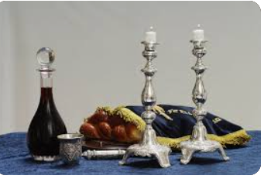

A woman told the following story in a video recently posted online:

“I took knives, went to the bomb shelter, gave every kid a knife, and said to them, ‘Listen up, this is not a normal situation. It has never happened before.’ Suddenly, I looked through the peephole, and I saw six terrorists, guns drawn, loudly chanting in Arabic. And I’m standing there with two knives in my hands, with my children behind me, and I’m still looking through the peephole, just unable to believe this is happening.
“And in that moment, I raised my eyes to G-d, and I said, ‘Hashem, I am promising you right now that I will keep all my Shabbats until the day I die. Protect me and my children because we are in danger. I refuse to acknowledge this as my end. I haven’t finished my tikkun. Borei Olam, I am begging you for mercy.’”
Tears filled her eyes and those of the women to whom she was speaking.
She continued emotionally, “And the minute I committed to keeping Shabbat, they just skipped over my house. They simply vanished!”
Every mitzvah counts. Every. Single. One. We must commit to taking upon a new mitzvah or perhaps pledge to intentionally do one to which maybe we don’t pay such great attention. Hashem is listening. He is eagerly waiting for us to bring Mashiach speedily in our days. What can you commit to today?

Reprinted from the Parashat Vayera 5784 email of Jack E. Rahmey based on the Torah teachings of Rabbi Amram Sananes

The Chofetz Chaim’s Love
For an Important Mitzvah
Rabbi Yoni Schwartz

After the passing of the Chofetz Chaim’s first wife, Faige, in 1891 he remarried. Every year, he built the sukkah himself. Even as he got older, the sage continued to build it himself, despite it being difficult, out of his love for the mitzvah. One year before Sukkos, after he married a second wife, Basya, she was about to leave to go grocery shopping and unthinkingly told him the sukkah might be better off in a different location – after he had already built it.
Without saying a word, the Chofetz Chaim disassembled it and reassembled it in a different spot. After Basya returned, she commented again, saying that the sukkah looked better in its original spot. Again, silently, the Chofetz Chaim took everything apart and rebuilt it. The amount of patience he displayed to protect Shalom Bais was superhuman.

Reprinted from the Parshas Vayeira 5784 email of Torah Sweets.

A “Childish” Mistake

Tamir was very firm and secure in his decision to become a ba’al teshubah, but his brother Amos was still vacillating. He believed and he didn’t believe, wanted but didn’t dare, was afraid to try yet afraid to fail. Tamir would reassure him over and over, but Amos was too scared to take the plunge. At a certain point, they decided to go to Rabbi Chaim Kanievsky in Bnei Brak, and ask him about Amos’s doubts and concerns.
The taxi made its way through the crowded streets of Bnei Brak to the corner of Hazon Ish and Admor MiGur Streets and stopped for the brothers to ask directions.
“Excuse me, little boy. Where is Rabbi Chaim Kanievsky’s house?”
“Get out here,” the boy said, “and go straight down this street till you get to Meltzer Street. Harav Kanievsky lives across the street from the Wagshall wedding hall, I think.”
They paid the driver, got out and started walking. They were approaching Meltzer Street when suddenly two boys came running up the street after them, huffing and puffing for all they were worth. “Excuse me,” one of them said, out of breath. “Are you the ones from the taxi who asked directions?”
The brothers confirmed that, yes, they were indeed.

I Sent You to the Wrong Place
“I’m so sorry, really sorry. I made a mistake. After you left, just to be sure, I asked my friend, and he told me I had sent you the wrong way. You’re completely in the wrong place.”
Amos couldn’t help smiling. Imagine one of the kibbutz children going out of his way like this, he thought. Not likely. There was something about the tenor of the whole incident that he had never before encountered.
The boy begged them to let him take them where they needed to go, all the way to the door. “I’ll just call my parents and tell them I’ll be a little late,” he said. “I know exactly where the Rav lives now.”
The second boy tugged at his friend’s sleeve and whispered loudly, “I think you have to pay for their taxi.”
The first boy began to apologize even harder. “Of course, I’ll happily pay for a taxi for you to get there. After all, I made the mistake. I haven’t got any money, but if you come home with me – it’s not far – my parents will pay for you to take another taxi. I should never have sounded so sure of myself when I didn’t really know where the Rav lives.”
Amos’s eyes filled with tears. He took hold of Tamir’s arm and said, “We don’t have to go to a Rav, Tamir. Let’s go home. I want to do teshubah. If this little boy is an example of what it’s all about, I am going to go all the way.”
A little touch of hashgachah peratit and a whole lot of kiddush Hashem, and a good measure of hesed propelled Amos into the warm embrace of his heritage. (There is no such thing as coincidence)

Reprinted from the Parashat Vayera 5784 email of Rabbi David Bibi’s Shabbat Shalom from Cyberspace

Reflections on Israel Today
By Rabbi Yosef Farhi

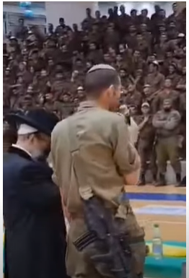

My father, who fought in the Yom Kippur war, is crying, as he watches the videos of the soldiers accepting on themselves the Yoke of Heaven, before entering Gaza… He told my mother that even before the Yom Kippur war, which caused a huge wave of Ba’alei Teshuva, the soldiers did not have a spiritual awakening of the magnitude of what we are seeing now!
There isn’t a soldier who wants to enter Gaza without tzitzit and a siddur. That is the bullet-proof vest they want! More than food, gear, the soldiers want Tzizit and Tefillin! Hello, Mashiach - did you hear that?
A mother asked her daughter-Chayelet-soldier to find a nice soldier Chayal guy, that maybe she can marry… The daughter texted back to her mother, Ma! I can’t know who to choose from the soldiers! Everyone looks religious, everyone is wearing tzizit! I don’t know who is religious and who is not! Eliyahu Hanavi, where are you?
****************************************
There was a religious family from Kfar Aza, on that day before Simhat Torah, that went to visit their parents in Jerusalem. The grandparents said, “Why don’t you stay with us for the holiday of Simhat Torah?” But the parents said, “We are part of the Kfar Aza community and we want to celebrate with our community Simhat Torah”. The grandparents did not give up. They said, “We are making food for you; just stay with us for the holiday!” They went back and forth, and unfortunately, this family decided not to listen to their grandparents, and went back to Kfar Aza for Simhat Torah…
They got home. And this was the last time they went home. The mother asked the father if he could open the door with the key, because she had to cook for the holiday. The father put his hand in his pocket, and the key wasn’t in his pocket! He forgot his key at Saba and Savta’s! They started arguing about how this could have happened, until they decided that they should go back and spend Simhat Torah in Jerusalem… after all, they had a meal already prepared for them!
Tell me that G-d is not watching!!!

Reprinted from the Parashat Veyera 5784 email of Shabbat Shalom from Cyberspace.

Survivor Celebrates 90th Birthday in Auschwitz
With 100 Descendants
By Tzemach Feller

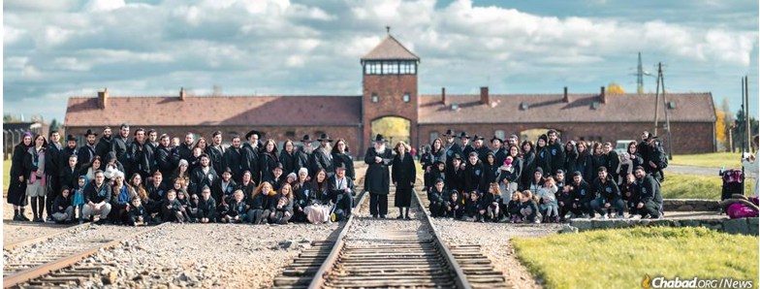
Rabbi Nissen Mangel celebrates his 90ths birthday in Auschwitz with his wife, children, grandchildren, and great-grandchildren, 80 years after he arrived there on a cattle car as a child. Photo: Yisroel Teitelbaum

Rabbi Nissen Mangel’s entire life has been a miracle.
He was a 10-year-old child when he came to Auschwitz in a clattering cattle car stuffed with humanity.
Not many 10-year-olds were sent to the right, towards life, by the infamous Dr. Josef Mengele. But Mangel was.
Not many 10-year-olds survived Mengele’s sadistic human experiments. But Mangel did.
And not many 10-year-olds survived five other slave labor and concentration camps and a forced death march in the dead of winter.
But Mangel not only survived, he thrived.
“My father’s motto in life is: Hodu LaHashem—‘Give thanks to G-d,’ ” Rabbi Nochum Mangel, who directs Chabad-Lubavitch of Greater Dayton in Ohio, told Chabad.org. “And his message was the same for the future. Hitler tried the final solution and he failed, and the Nazis of today—Hamas—will fail as well.”
The trip was the product of a complaint.
Mangel’s children, who serve in leadership positions around the world, many as Chabad-Lubavitch emissaries, would get together from time to time, and had, on occasion, traveled to Europe to retrace their father’s early life.

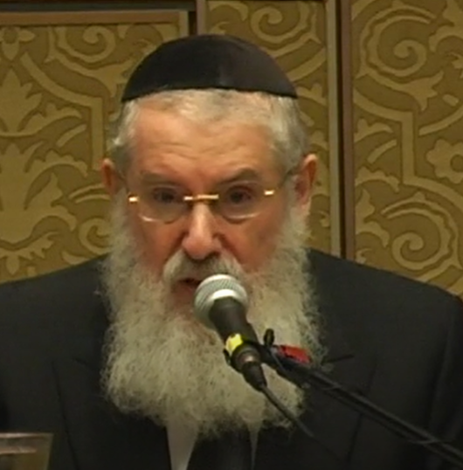
Rabbi Nissen Mangel

“My father always wanted his children to go see where he grew up—Košice, Slovakia—and also Auschwitz, where he was taken,” Nochum Mangel related.
But the grandchildren felt left out. They, too, wished to participate in the family pilgrimages, to understand the horror their grandfather had endured and his gratefulness to G-d for surviving.
So, they started planning. The rabbi’s 90th birthday was approaching, and what better way to celebrate it than at Auschwitz with his entire family—his wife, children, grandchildren and great-grandchildren.
And so, they started organizing.
They’d stop off in Krakow, Poland, to visit the resting place of R. Elimelech of Lizensk, to whom Rabbi Mangel traces his ancestry, and would continue on to Auschwitz.
And on Thursday, 11 Cheshvan, surrounded by nearly 100 family members, Mangel pointed to the spot where he came off the train, where he was sent to the right, to life, and said: “Blessed be He who performed a miracle for me at this place.”
In 1944, together with his father, mother and elder sister, young Nissen Mangel had been caught by the Nazis, arrested and deported from Bratislava. He was first sent to the Sereď labor camp near Bratislava, then on to Auschwitz, where he was selected as one of the subjects of Dr. Josef Mengele’s horrific human experiments. He was sent on to Birkenau, Mauthausen, Melk and Gunskirchen, from which he was liberated in 1945 after surviving a forced death march as the Nazis fled the oncoming allied armies.
Mangel has told his story of triumph to hundreds of communities and thousands of people.

More than Just Survived the Holocaust
But Mangel did not just survive. He embraced the very faith that his tormentors had tried to stamp out. He became a prolific author and translator; his translated works include the Tehilat Hashem prayerbook, the High Holidays Machzor and Shaar Hayichud VeHaemuna, the second volume of Tanya.
Rabbi Mangel is the rabbi of Congregation Ksav Sofer in Crown Heights, Brooklyn, N.Y. He has lectured throughout the world. He teaches each morning and evening as he has done all his life, infusing his perspective of gratitude and faith in G-d into everything he does.
At the family Shabbat dinner, the following evening in Warsaw, grandson Mendel Mangel spoke, describing the incongruity of their visit and how crucial it was, taking place during the ongoing war in Israel.
“As we toured Auschwitz, there were many other groups visiting as well. They were asked—as everyone is—to respect the solemnity of the place, ground made sacred by the blood of millions murdered for being Jewish,” he recalled.

Songs of Thanks to G-d
“And there we were, singing songs of thanks to G-d. They were there to learn about the atrocities that took place there—and it’s so important that the world know about them—but we were there not only to remember the destruction, but to thank G-d and to celebrate that G-d will never abandon us, that the Jewish people will always survive, come what may.”
One of the songs the Mangel family sang as they stood in front of Auschwitz was “Vehi She’amda,” which means, “And this is what kept our fathers and what keeps us surviving. For, not only one arose and tried to destroy us, rather in every generation they try to destroy us, and G-d saves us from their hands.”
Yes, there were moments of solemnity and tears as the family walked through the gas chambers and the barracks; when Mangel found the names of his murdered family in the thick book of victims of the camp; and when they prayed Minchah and the elder Mangel recited Kaddish for his father, who was murdered during the Holocaust. But echoing his own life, the focus was not on what was lost but on what had been built out of the ashes.
“Every Jew who survived that inferno is a miracle,” Rabbi Nochum Mangel said, quoting his father. “And that is what my father wanted to teach the next generation: He wanted to tell his children, grandchildren, and great-grandchildren his story so they should know that despite the hatred and persecution, Jewish life continues.”

Reprinted from the November 2, 2023 posting on the website Chabad.Org

The Rabbi and the
Shabbos Desecrator

Rav Shraga Freedman relates a beautiful story. The residents of the Ezras Torah community in Eretz Yisroel were bothered by a stranger who would drive around the neighborhood every Shabbos. Some people began protesting, but Rav Hershel Zaks took a different approach. He got a good look at the license plate number, and he memorized it.
After Shabbos, he was able to use the license plate number to get this man’s address. He then went over to his house and knocked on the door. A little boy opened the door and called over his shoulder, “Some religious people are here!”
His father shouted back, “Give them a Shekel!” However, Rav Zaks said to him, “We’re not here for money. We would like to talk to your father.”
The man came to the door. Rabbi Zaks gently explained how the Jews of Ezras Torah were pained by the car in their streets on Shabbos.
The man replied, “You’re crazy, but you’re right. I won’t drive on your streets any more on Shabbos.”
The Bar Mitzvah Invitation
About a year and a half later, Rabbi Zaks received an invitation to a Bar Mitzvah. At the Simchah, the father of the Bar Mitzvah boy approached him and said, “Rabbi, do you recognize me?”
Rav Zaks was not sure he could remember him, and the man said, “About two years ago, you came to my door and asked me not to drive in Ezras Torah on Shabbos. Because you cared enough to explain and talk to me like I mattered, I decided to find out more about being religious, and I am now Shomer Shabbos. I started sending my child to a religious school, because I want him to learn how to emulate you!”

Reprinted from the Parshas Vayeira 5784 email of Rabbi Yehuda Winzelberg’s Torah U’Tefilah.
The Strange Remarks
of Rav Shmelka

Rav Shmelka Horowitz, zt”l, was on his way to being appointed as the new Rav of Nikolsberg, when his new Gabai, Chaim Yankel, overheard a strange “conversation” taking place in Rav Shmelka’s new office.
“Shmelka, you are a Tzadik,” he heard the Rav whispering in the empty room. “Shmelka, you are a Gaon! Shmelka, there is no one like you in all of Nikolsberg. No, in all of Poland. No, in all of Europe. No, not even in the entire world!”
The odd tribute finally came to a close. Knocking tentatively on the door, the Gabai stepped in, looking somewhat bewildered. Rav Shmelka noticed his Gabai’s expression, and with a smile he inquired, “So, Chaim Yankel, you heard my little speech? What did you think?”
Of course, the Gabai, who was actually quite shocked, answered, “Well, Rebbe, I thought you were all alone, but I must have been mistaken. But now I see that you are here alone, so I am confused.”
Rav Shmelka explained to the Gabai, “I am afraid that since the custom is to praise the incoming Rav beyond his actual attributes, I would become filled with arrogance, so I decided to praise myself first. I know how ridiculous I sound when I do this, so when I will hear others praise me, I will realize that they are all just empty words, just like the words I said myself, and it will mean nothing. I can therefore avoid feeling any kind of Ga’avah!”

Reprinted from the Parshas Vayeira 5784 email of Rabbi Yehuda Winzelberg’s Torah U’Tefilah.

A Coin and a Kiss
By Rabbi Sholom Avtzon

As is well known, the [Lubavitcher] Rebbe Rashab (Rabbi Sholom Dovber Schneersohn, 1860-1920) was a forceful opponent of the Zionist movement. As such, the chassidim were concerned that if he would continue in this vein, the Zionists would retaliate and try to harm him. Their apprehension grew when he wrote an extremely sharp public letter against the movement.^{[1]}
The chassidim knew it was out of the question for them to suggest to the Rebbe himself that he reduce his struggle against the Zionists. Instead, they decided to speak to his mother, Rebbetzin Rivkah, and persuade her to suggest that the Rebbe use a more cautious approach. The Rebbe had tremendous respect for his mother, and if she would just mention a word of caution, they were certain everything would be taken care of.

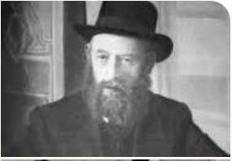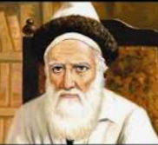
From left to right: the Rebbe Rashab and the Tzemach Tzedek

Upon hearing their request, Rebbetzin Rivkah replied in astonishment: “You want me to tell him what to do?! I would never ask him to change his mind or opinion. Evidently, you don’t realize what a gleicheh [straight] mind he has.”
She then related the following story:
When the Rebbe Rashab was a young boy, he and his older brother, Reb Zalman Aharon (the Raza), would visit their grandfather, my father-in-law the Rebbe the Tzemach Tzedek [Rabbi Menachem Mendel Schneersohn of Lubavitch, 1879-1866], on a daily basis. At the end of the visits, the Tzemach Tzedek would usually give each one a coin.
In beis harav (the Rebbeim’s family), it was customary for the children to wear a shtreimel (and gartel) when entering the Rebbe’s room to speak with him. The [Rebbe] Rashab and the Raza each had a shtreimel which they would put on before visiting the Rebbe the Tzemach Tzedek.
One day, the Raza couldn’t find his shtreimel, so at the scheduled time, the [Rebbe] Rashab went alone.^{[2]}
Upon entering the room, his grandfather picked him up and sat him down on his lap for a long period of time.^{[3]} He then gave him a five-kopeck coin and kissed him.
When he returned home, he excitedly announced that today, in addition to receiving the usual coin, he received a kiss as well.
The Raza realized that the kiss had great significance^{[4]} and was extremely upset that he had missed this special occasion. Frustrated at his misfortune, he grabbed the coin out of his brother's hand.
The [Rebbe] Rashab cried out, “You can grab the coin Zeide gave me, but you can’t take away the kiss!”
Realizing that what he had done was wrong, the Raza immediately handed back the coin. However, the [Rebbe] Rashab refused to accept it, saying, “You keep the coin and I’ll keep the kiss.”
Concluding the story, Rebbetzin Rivkah said to the chassidim: “If at such a young age he was able to understand the difference between a coin and a kiss, how can one possibly think that now, when he is Rebbe, he doesn’t understand what he should do?! If so, how can I give him advice?!”
I [heard this story from Rav Yitzchok Raphalovitch, who was one of the chassidim who approached Rebbetzin Rivkah with this request.

Reprinted from the Parshas Vayeira 5784 email of the Weekly Story of Rabbi Sholom Avtzon, a veteran mechanech and the author of numerous books on the Lubavitcher Rebbeim and their chassidim.

More Zechusim
By Rabbi Chaim Arye Zev Ginzberg

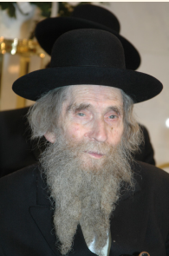
Rav Aharon Leib Shteinman
An elderly Yid was approaching his hundredth birthday and was greatly troubled. Every day, he would share with his son the reason for his agitation. “I need to understand why I am zocheh to this arichus yamim,” he said. “My father died at 46 and his father before him at 41. I am a simple person, not learned or accomplished. Why have I been zocheh to live until this old age?”
Any response that his son shared with him was inadequate. Concerned for his elderly father’s well-being, the son decided to present his question to the gadol hador, Rav Aharon Leib Shteinman. The rosh yeshivah’s answer was absolutely mind-boggling,
and could only have come from someone whose vision of the happenings of this world is worlds apart from our own.
The rosh yeshivah responded, “Tell your father the following reason why he is zocheh to arichus yamim. Hakadosh Baruch Hu is working to bring an end to Galus Edom.
The zechus that Edom had all these years was the great kibbud av that Eisav accorded his father. And so, Hakadosh Baruch Hu, in recent times, has changed the nature of the world, allowing people to live longer. This way, Klal Yisrael can care for their elders for a longer period, generating additional zechusim of kibbud av to counteract the zechus of Edom and finally bring an end to Galus Edom.”
In other words, this person was zocheh to arichus yamim so that more zechusim could be generated by his children, to benefit Klal Yisrael. What an astounding idea! What our simple eyes see as the good fortune of increased life expectancy is really part of Hakadosh Baruch Hu’s plan to bring the geulah.

Reprinted from the Parshas Lech Lecha 5784 edition of At the ArtScroll Shabbos Table. (Excerpted from the ArtScroll book – Rays of Hope

Giving In
By Rabbi David Sutton and Dr. David Katzenstein

Rav Elazar Menachem Man Shach served as rosh yeshivah of Yeshivas Ponevezh in Bnei Brak for close to fifty years. Known for his incredible insight into human nature and spot-on advice, his exemplary character traits were evident in his home life, as well.
“When we talked about getting married,” Rav Shach’s wife once shared with his students, “my husband proposed that we take turns giving in to each other. He’d give in to me during our first disagreement, and I’d give in the next, and so on. In this way, there would be no ill will or hard feelings, since we both knew that things would even out the next time around. After telling me about his idea, my husband said he’d be the first one to give in.”
The students expected to hear that she got the next turn, but she explained, “I never had my chance to be the one to give in. My husband always ‘took my turn.’” Rav Shach always gave in. Every. Single. Time.

Reprinted from the Parshas Lech Lecha 5784 edition of At the ArtScroll Shabbos Table. (Excerpted from the ArtScroll book – The Art of Being You!

The Chefs of Tel Aviv
By Rebbetzin Chaya Sora Gertzulin

Eis tzarah hee l’Yaakov, It is a time of deep pain and tragedy for Klal Yisroel. We are all walking around with aching hearts. We are one nation, one people, all connected. The pain of our brothers in Eretz Yisroel is our pain. We cry, we daven, for those being held in captivity, for the injured, for the lives lost, and for their families. It is a tragedy so horrific, the numbers so many, it’s hard to fathom.
At the same time, we hear stories of inspiration. Stories of amazing strong men and women, doing the best they can for Am Yisroel, giving it all they got. Stories that give us hope and warm our heart.
Tel Aviv is a lively, busy city, home to many restaurants. Diners frequent its upscale steakhouses, and Israeli-style food joints.
While a large segment of the population was called up by the army, and family members at home aren’t eating out, the restaurants are anything but empty. They are filled with extra chefs, staff, and volunteers, going all out for Chayalei Yisroel, those on the front lines, fighting for the Jewish nation.

A Burden to Overcome
Before supplying meals for the soldiers, many of the Tel Aviv restaurants had a hurdle to overcome. Some restaurants in this city unfortunately did not maintain kosher kitchens, or were kosher “style”, while others, whose owners kept their kitchens nominally kosher, didn’t have a teudah, a kashrut certification. But their desire to help, to do chesed, was so strong, that they undertook the proper measures to kasher their restaurants and receive certification.
As chef Shalom Simcha Elbert of OCD (one of the top restaurants, known for the chef’s meticulous care that goes into every dish – hence the name OCD) said, “The restaurant now has kosher supervisors and is closed for Shabbat… We want to feed people in a way that will honor them.”

20,000 Meals a Day
Ha’achim, another bustling Tel Aviv restaurant, also went through a kashering process, and is now preparing twenty thousand meals a day for the soldiers. Chef Yoatim Doktor plans to increase the production next week, by providing freshly cooked meals for the displaced surviving families of the horrific massacre in the south. The gourmet chef will be making schnitzel-pita sandwiches, and other child-friendly foods.
There are even some vegan and gluten-free restaurants that received a kashrut teudah. They too wanted to join the effort to provide special meals for those who requested it, as well as for hospital patients.
Reprinted from the Parshat Noach 5784 email of Torahanytime.com Newsletter.

